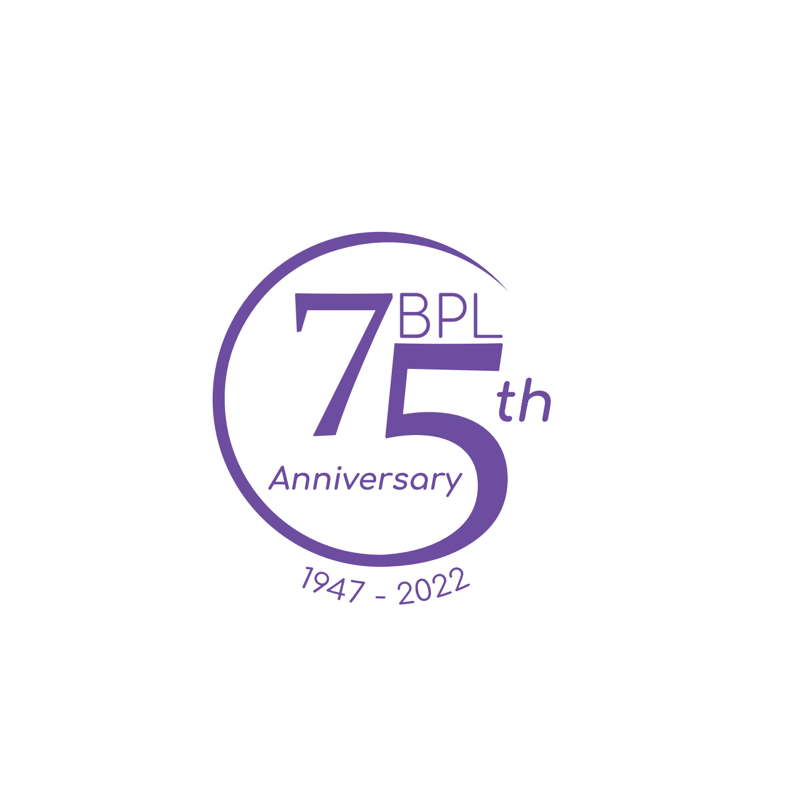
Beauregard Parish Library
205 S. Washington Ave
DeRidder, La 70634
Beauregard Parish Library Board of Control Minutes

The Library Board of Control met virtually on February 7, 2022 in an open meeting via the Zoom platform. President Angela Lannen called the meeting to order at 4:31 and noted a quorum made up of Jo Blankenship, Lynne Boggs, Tranquil Crosby, Beth Cuevas, Molly Poe, and Kelly Bailey, as well as herself. Candice Hodges was absent. Director Erin Chesnutt and architect David Brossett were also present.

- Blankenship moved to amend the agenda to include under New Business: Approve Erin Chesnutt as an authorized applicant to seek Hazard Mitigation funds to assist in installing a whole-building back-up generator; and Amend wording in Employee Manual sections 6.6.2 and 6.6.3. Cuevas seconded and the motion carried.
- Boggs moved to approve the minutes from the Nov 1, 2021 board meeting and the Nov 29 public hearing and budget meeting. Blankenship seconded and the motion carried.
- Cuevas moved to re-elect Lannen and Blankenship as board president and vice-president, respectively. Poe seconded and the motion carried. Blankenship moved to set the remaining meeting dates for 2022 as May 2, Aug 1, and Nov 7, 2022 at 4:30 pm. Poe seconded and the motion carried.
- Architect David Brossett presented the plans for the East Beauregard branch building to the board. Blankenship approved asking the Police Jury to approve seeking bids for the project as soon as Brossett can get the paperwork together. Cuevas seconded and the motion passed unanimously.
- Chesnutt announced that the library has an MLIS student interning for 200 hours this spring semester and shared that she will be assisting with tracking metrics and output measures among other tasks. Chesnutt also shared that the LLA conference has been delayed until July; the PLA conference will take place in Portland, Oregon March 23-25. Trustees wishing to attend should connect with Chesnutt before Feb 16 to make arrangements.
- Chesnutt also reminded trustees of mandatory annual training with the Ethics Commission, and 2 one-hour long classes on preventing sexual harassment. The mandatory financial disclosure form is due to the State Board of Ethics by May 15. Chesnutt will be submitting a packet on May 5 via certified mail; trustees are welcome to bring their completed forms by before then to be included in this packet.
- Chesnutt reviewed the final amendment proposal for fiscal year 2021’s budget. Blankenship moved to approve the proposal and the amendments for FY 2021 and 2022; Boggs seconded
- and the motion carried. The final, amended budget for 2021 is:

REVENUES | Final Budget 2021
Ad Valorem | $2,155,997
State Revenue Sharing | $54,628
Other
Fees (Library use) | $6,031
Fines | $2,925
Gifts & Grants | $58,509
Refunds/Reimbursements | $94,975
Interest | $525
Balance Forward | $3,385,739
Total | $5,759,329

GENERAL FUND EXPENSE | Final Budget 2021
Personal Services | $1,262,243
Operating Services | $162,373
Materials & Supplies | $38,152
Library Materials | $237,764
Equip. & Furnishings | $5,354
Training, Ed. & Travel. | $13,357
Intergovernmental | $76,266
DESIGNATED FUNDS EXPENSE
Grant Match | $0
Bld/Asset, Repair/Replace | $34,509
EB Capital Expense | $0
SB Capital Expense | $0
Singer Capital Expense | $236,017
Hillman Fund | $0
McElvin Bequest | $0
75th Anniversary | $9,441
FEMA Expense | $93,027
Rotary Grant Expense | $383
ARPA Expense | $43,577
Total | $2,212,463

2021 Fund Balances
Beginning Fund Balance | $7,478,761
2021 Revenues | $2,373,590
2021 Expenses | -$2,212,463
Ending Fund Balance | $7,639,888
Designated in 2022 | $4,226,054
Undesignated in 2022 | $3,413,834

and the amendments for the FY 2022 budget are:
2022 BARR Designated Fund: $2,696,998
2022 Singer CapEx Designated Fund: $193,983
2022 75th Anniversary Designated Fund: $6,559

- Cuevas moved and Poe seconded approving Kolder, Slaven, Champagne & Co, LLC to perform our 2021 audit and SAUP report. The motion carried.
- Blankenship moved to approve the compliance questionnaire form as presented for FY 2021; Boggs seconded and the motion carried.
- Chesnutt shared some of the library’s goals for mid-year including increasing foot traffic in the buildings by 10 %, traffic on the Student Resource webpage by 10%, and circulation of physical materials by 15% all by 6/1/22.
- Blankenship moved to approve Chesnutt as an authorized applicant for FEMA Hazard Mitigation grant funds. Cuevas seconded and the motion carried.
- Boggs moved to approve new wording in Employee Manual sections 6.6.2 and 6.6.3. Blankenship seconded and the motion carried.
- Chesnutt provided an update on the Singer renovation project. The project in currently within budget and slated to remain that way. There has been a delay in the ISP’s permitting and supply shortages may mean our options on furnishings are limited to wooden shelves instead of metal. We hope to have the branch open and running in March or April 2022.
- Julie Moncada provided written reports for the Website Committee and 75th Anniversary Committee activities:
  - The new website is live, as of Jan 29. The URL remains library.beau.org
  - The Anniversary Committee held a wonderful kick-off event on Jan 15 featuring activities at all locations, speakers and presenters at the DeRidder location. We had over 90 visitors at the DeRidder location in 4 hours that day. Participants of the Diamond Club reading challenge are already turning in their first logs.
- Chesnutt shared the YTD financial report. Cuevas moved to amend the budget to include a designated expense budget of $10,276 for Rotary Grant Expense. Poe seconded and the motion carried.
- Other reports reviewed included circulation, usage statistics, and personnel, facilities, and community involvement.

With no other business, Lannen adjourned the meeting at 6:02 PM.

Respectfully submitted,

Erin N Chesnutt,
Secretary to the Board

